M.Sc. Information Security Lab Assignment – LAB 2

Name- Harshit Kumar More
Roll No - 16

Task 1: Password Strength Analysis
Tool Used: Online Password Strength Checker
Website: https://www.passwordmonster.com
Observation:
Weak passwords can be cracked within seconds, while strong passwords take years to crack.
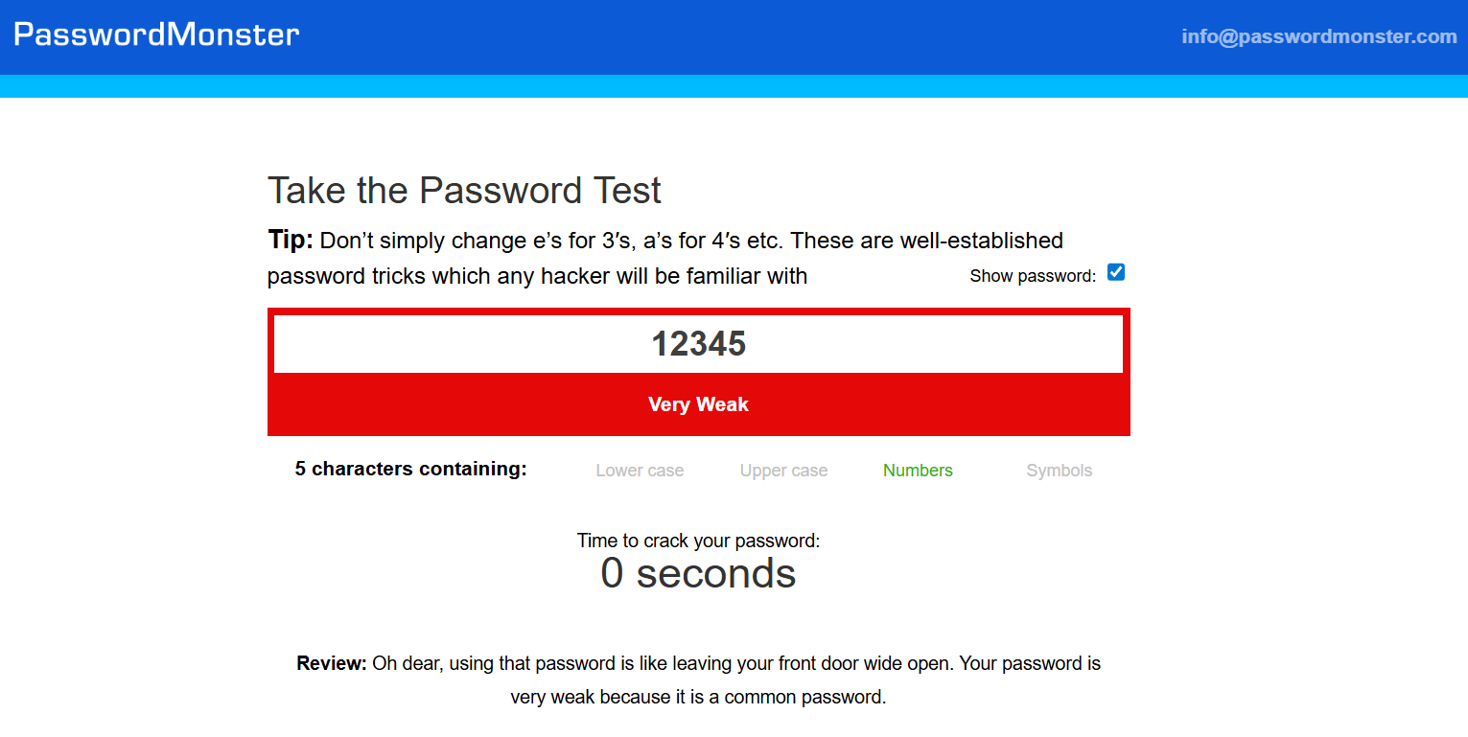
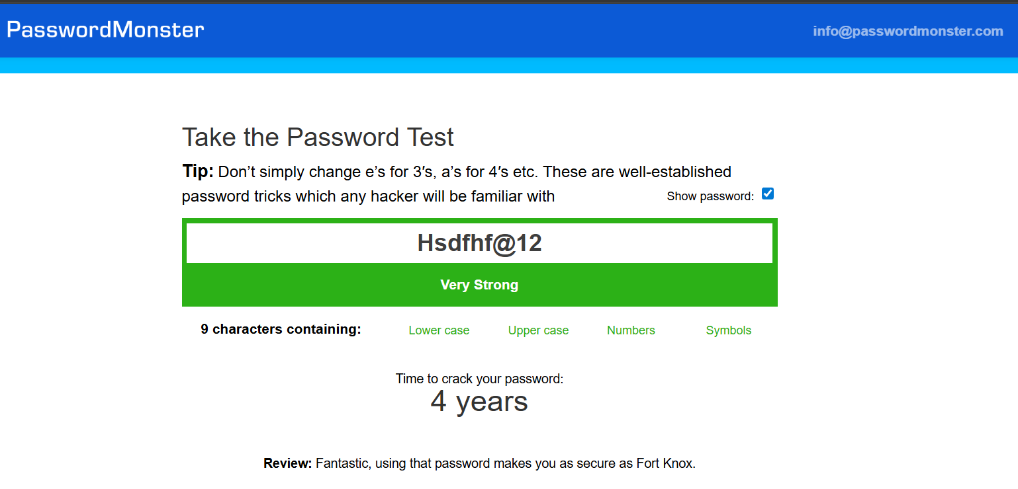
Cracking time: Here we can see that the password “12345” which contains sequence of numbers takes time of 0 seconds to crack whereas the other one “Hsdfhf@12” contains random combination of uppercase, lowercase letters symbols and numbers making it hard to crack so it takes 4 years to crack.

Task 2: Password List Generation using Crunch
Tool Used: Crunch (Kali Linux)
Command Executed:
crunch 4 6 abcd12 -o passwords.txt
Observation:
Crunch generates customized wordlists by creating all possible combinations of characters based on the defined minimum and maximum password lengths and the selected character set. By varying these parameters, the size and complexity of the generated password list change significantly, making Crunch a powerful tool for simulating real-world dictionary and brute-force attacks in password cracking, security testing, and penetration testing scenarios.
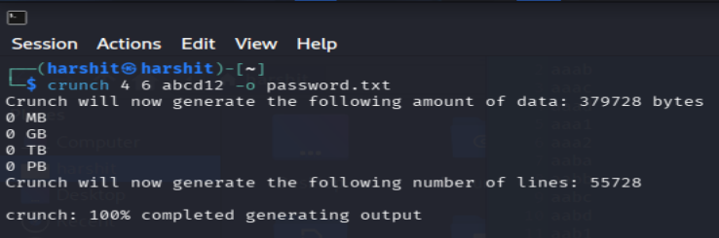
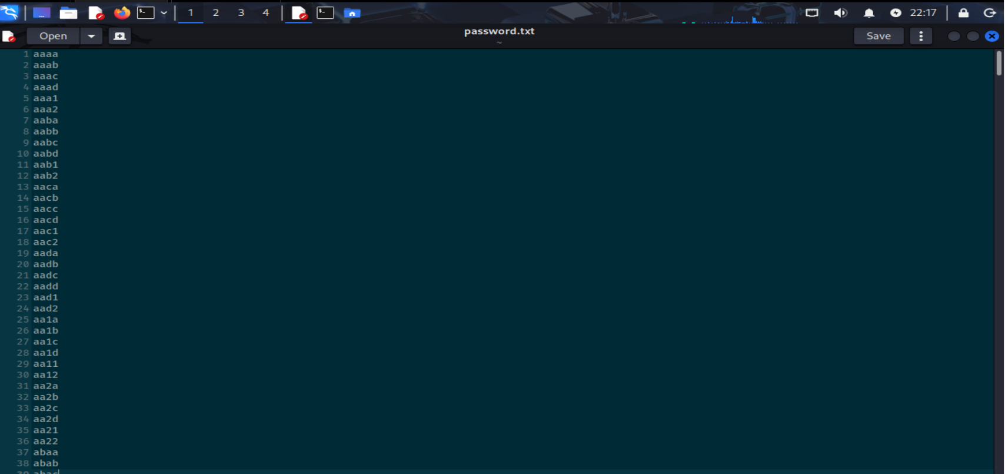

Task 3: Hash Identification
Website: https://hashes.com/en/tools/hash_identifier
Risk:
MD5 hashes are weak and can be cracked easily using rainbow tables.
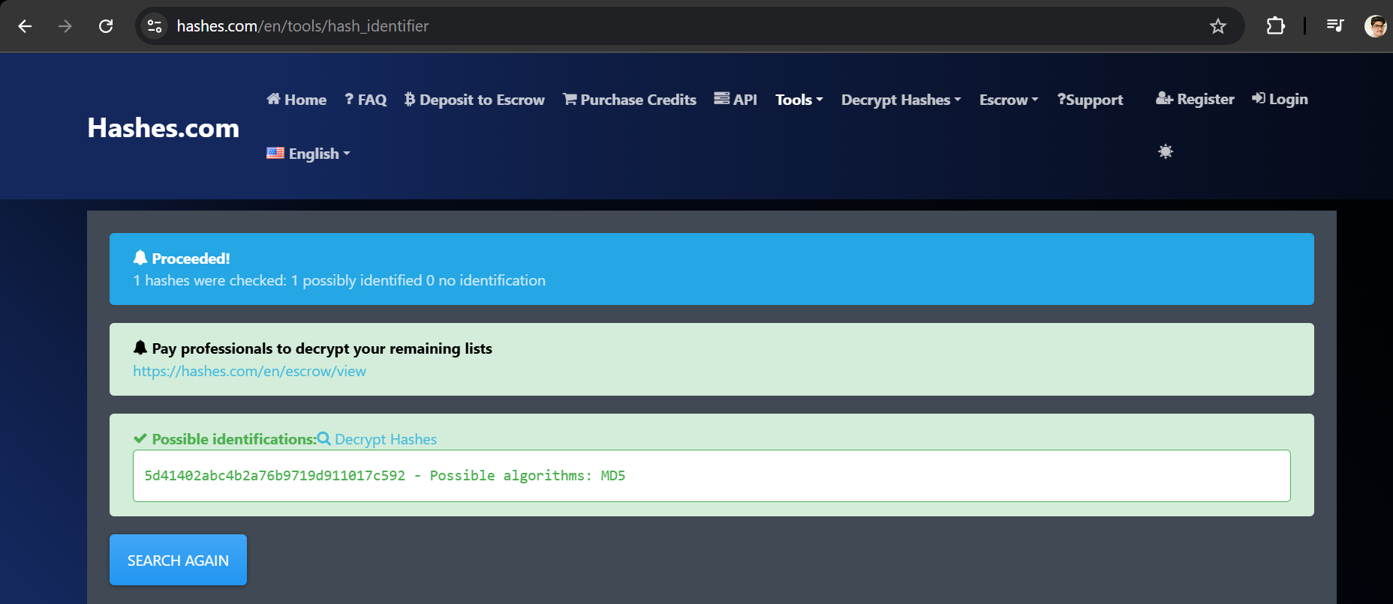
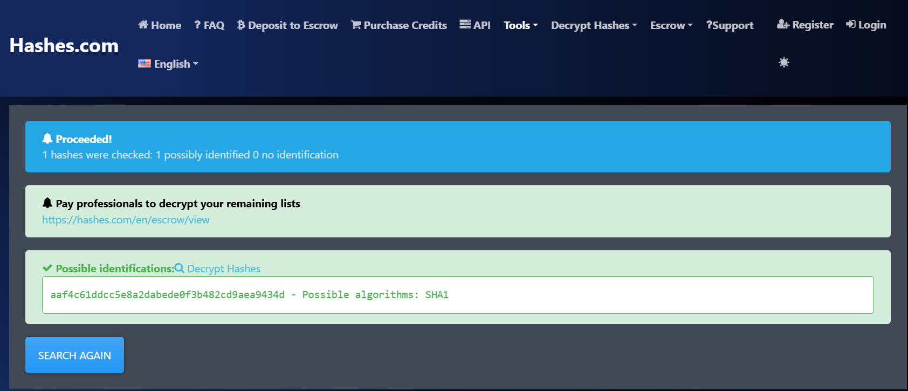

Task 4: Malware Analysis (Case Study)
Selected Malware: Ransomware
1. Description
Ransomware is a type of malicious software designed to encrypt a victim’s files or entire system, making them inaccessible. After encryption, the attacker demands a ransom payment, usually in cryptocurrency, in exchange for the decryption key. Even after payment, there is no guarantee that access will be restored.
2. Infection Method
Ransomware commonly spreads through the following methods:
- Malicious Email Attachments
Emails disguised as invoices, job offers, or official notices contain infected attachments or links.
- Infected Websites (Drive-by Downloads)
Visiting compromised or fake websites can automatically download ransomware without user knowledge.
- Software Cracks and Pirated Applications
Downloading unauthorized software often includes hidden malware payloads.
. 3. Impact
- Loss of access to critical files
- Financial loss due to ransom demands
- Business downtime and reputational damage
- Possible data leakage if attackers threaten public release
4. Prevention Methods
Effective preventive measures include:
- Regular Data Backups
Maintain offline and cloud backups to recover data without paying ransom.
- Antivirus and Anti-Malware Software
Keep security software updated to detect and block ransomware.
- User Awareness and Training
Educate users to identify phishing emails and suspicious links.
- System and Software Updates
Patch vulnerabilities regularly to prevent exploitation.

Task 5: Risk Analysis Table

Threat | Vulnerability | Risk
Phishing | Lack of user awareness | Credential theft
Weak Password | No password policy | Account compromise
Malware | Outdated antivirus software | System damage and data loss
Ransomware | Lack of regular data backups | Data encryption and financial loss
Spyware | Installation of untrusted software | Loss of privacy and data leakage
Insider Threat | Excessive user privileges | Data theft or system sabotage
Denial of Service (DoS) | No traffic monitoring or filtering | Service unavailability
Unpatched Systems | Missing security updates | Exploitation of system vulnerabilities

